**Website Wording/Layout**

(Home page)

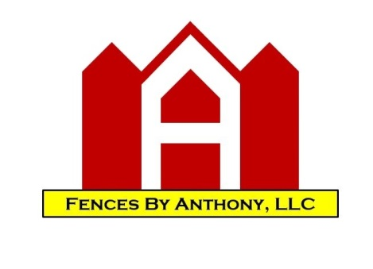

Serving Our clients for over 20 years

Give Us a Call at 615.367.1588

*Stylish and Structurally Sound*

**FENCES – DECKS - GATES – ARBORS & PERGOLAS – OTHER SERVICES –GALLERY – TESTIMONIALS – ABOUT US – CONTACT US – FAQ**

Fences (drop down) Decks (drop down)

**Free Consultation!**

First and Last Name

Email

Phone Number

Comments

Wood Wood

Metal Composite

Vinyl

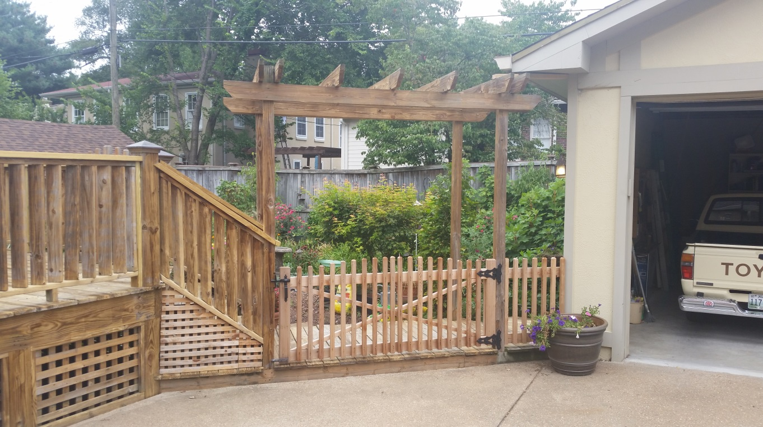

**Receive free maintenance inspections and deals by joining our Emailing List**

**Email**

**BBB Symbol - PayPal, Visa, MasterCard, Discover Symbols**

|Home – About Us – Contact Us| Copyright © 2011 - All Rights Reserved Fences By Anthony, LLC.

**(Wood Fences Page)**

**WOOD FENCES**

Wood is the most versatile material for building a fence. With many styles to choose from, wood fencing provides the  
privacy you need and the protection for your pets and family.

Benefits of a wood fence:

* It easily accepts stains and paints, adding warmth and beauty to your property.
* It is available in a variety of sizes and grades, wood fence systems permit unique designs to match and compliment your property.
* It naturally weathers, giving wood an economical advantage.
* It provides security, defines boundaries, protects property, and helps control noise, wind and sunlight.

Below some popular examples of wood fencing, however virtually any combination of each could be built. Also, FBA would be happy to entertain any other particular style that exists or comes to mind.

**WOOD PRIVACY FENCE**

Our privacy fencing is the most economical way to create a private setting in your back yard. Generally, 4×4 posts are used with 2×4 framing and 5/8x6x6 dog eared pickets are used. Gothic, French Gothic and rounded dog eared pickets are also available. We never use pre-made sections of wood fencing due to their poor quality and short longevity. Semi-privacy can be easily made by spacing the pickets.

More Info(link to more detailed page)

**(on detailed page)**

**Privacy Fence**

Our privacy fencing is the most economical way to create a private setting in your back yard. Generally, 4×4 posts are used with 2×4 framing and 5/8x6x6 dog eared pickets are used. Gothic, French Gothic and rounded dog eared pickets are also available. We never use pre-made sections of wood fencing due to their poor quality and short longevity. Semi-privacy can be easily made by spacing the pickets.

**Dog-Ear Privacy Fence**

Our Dog ear fencing is the most economical way to create a private setting in your back yard. Generally, 4×4   
posts are used with (3)2×4 framing and 5/8x6x6 dog eared pickets are used. Semi-privacy can easily be made by spacing the pickets. If you don’t see the particular style that you are looking for on our website, the possibilities are endless. Please contact us with any questions. We are open to new ideas and/or projects that may not be found on our website

### Table Top & Stair Table Top Privacy Fence

Each section of this fence is square and level to the earth. A stair step conforms to the contour of the land. This type of fence is not recommended for excessively slopped yards because height will be lost. The trim on top covers dog ear pickets for a more finished look.

Extras: Post caps, 6×6 posts

### Rolling Table Top Fence

Each section of the rolling table top fence is custom built to “roll” with the contour of the land. This type of fence is recommended when maximum height is desired. The trim on the top covers dog ear pickets for a more finished look.

Extras: Post caps, 6×6 posts

### Scalloped Privacy Fence

A scalloped wood privacy fence is constructed similarly to a dog ear fence. However, the top is cut with a dip or “scallop” between the posts. Framing can be built between the posts for a more finished look.

Extras: Gothic or French gothic posts

### Arched Privacy Fence

An arched fence is constructed similarly to a dog ear fence. However, the top of the fence is cut with an arch between the posts. Framing can be built between the posts for a more finished look.

Extras: Gothic or French gothic posts

### Gothic or French Gothic Privacy Fence

Gothic or French Gothic pickets can be used instead of dog ear for a more artistic or classic look.

### Shadow Box Privacy Fence

Shadow Box fences provide 100% privacy when looking directly toward them, but spacing allows light to come through at an angle. We recommend this style when the same look from either side is desired.

### Horizontal Privacy Fence

Horizontal fences have the boards running side to side as opposed to straight up and down. They can either be level with the earth or sloped with the land.

**(DETAILED PAGES)**

**Wood Picket Fence**

Wood picket fences are usually 4 feet tall and use a 4 inch wide picket with a 2 inch gap between pickets. The picket width and gap can be changed depending on what style is desired. We do install picket fences in front and back yards but are more commonly placed in the front yard providing a safe area away from the street for pets and children, also eliminating unwanted foot traffic. A front yard picket fence can provide a new artistic addition and dimension to the entire look of the front of your home.

Picket fences offer pet containment, security and beauty without sacrificing visibility.

### Dog Ear Picket Fence

Generally, these are pine   
or cedar 4′ tall with 2″ picket spacing. Our dog ear picket fence is the most economical and most basic privacy fence. Generally, 4×4   
posts are used with (2)2×4 framing and 5/8x4x4 dog eared pickets are used with a 2” gap.

### Scalloped Picket Fence

A scalloped picket fence is constructed similarly to a dog ear fence. However, the top is cut with a dip or “scallop” between the posts. Framing can be built between the posts for a more finished look.

Extras: Gothic or French gothic posts, post caps

### Table Top Picket Fence

This four feet tall fence is created with boards spaced 2 inches apart. The trim on top covers the dog ear pickets for a more finished look.

Extras: Post caps, 6×6 posts

### Arched Picket Fence

A scalloped picket fence is constructed similarly to a dog ear fence. However, the top is cut with a dip or “arch” between the posts. Framing can be built between the posts for a more finished look.

Extras: Gothic or French gothic posts, post caps

### Gothic or French Gothic Fence

Gothic or French gothic fences use a pointed picket to add style.

Extras: Gothic or French gothic posts

**Split Rail Cedar Fence**

Split rail cedar fences create a rustic look while providing a barrier. This fence is generally created using 8’ sections with 3 or 4 rails.

**Wood and Wire Fence**

This fence is constructed using a combination of wood rail and metal fence, commonly seen at dog parks.

**(Metal Fences Page)**

**METAL FENCES**

**Metal Chain-Link Fence**

Chain-link fencing is probably the most economical and durable style of fencing.  It is made from galvanized steel or colored vinyl coated, is resistant to rust and is virtually maintenance free.   
  
It is available in 4′-5′-6′-8′ heights, commercial or residential strength and in bare galvanized or vinyl coated green or black.

**Metal Aluminum Fence**

Aluminum fencing offers a combination of durability, strength and a clean appearance. This fence is the perfect choice to complement any architectural or landscape design. Matching gates are available and all gates can be self-closing and self-latching.  
  
 Aluminum ornamental fences are ideal around pools and corrosive areas where steel and wooden fences would require maintenance.   
  
There are literally hundreds of sizes, designs, strengths and colors to choose from. 4′ tall black is available in stock all of   
the time, all others usually take around 2-3 weeks for us to get. FBA recommends the [Jerith](http://www.jerith.com/) brand.

**(Vinyl Fences Page)**

**VINYL FENCES**

Vinyl fences offer full privacy with a multitude of styles. Picket vinyl fences are also available. Vinyl fences are 3’, 4’, 5’, 6’, 7’ or 8’.

FBA recommends XXX brand.  
[View Merchants Metals Vinyl Styles](http://www.merchantsmetals.com/literature/lit_PVC_Brochure.pdf)

**(Decks Page)**

**Decks**

Custom wood or composite decks add valuable outdoor living space to your home. Our decks are constructed of   
either treated wood or composite material. All deck framing is wood and, at least, with 2×10′s and 6×6 posts.   
Each material has advantages and disadvantages. Here are some things to consider:

### Wood

### More info (link to more detail page)

* Will eventually rot if proper care is not received
* Has knots splinters and can warp
* Is stronger and resists scratches better than composite material
* Has a natural appearance
* Is about 1/2 the cost of composite material
* Needs to be water sealed every few years

### Composite Material

### More info (link to more detail page)

* Does not rot
* Does not warp and has a uniform texture
* Scratches easily
* Is around twice the cost of wood
* Has tendency to grow mold or algae
* Is virtually maintenance free
* Is available in many colors and styles

An easy way to consider your deck dimensions is to consider different lumber sizes and measure the area of the   
desired deck. Lumber is sold in 8′-10′-12′-14′-16′ increments. Longer sizes are available, but can get expensive    
Try to match your idea with this in mind so that the least amount of wood is wasted to minimize costs.

**(Arbors & Pergolas Page)**

**Arbors & Pergolas**

**(Other Services Page)**

**Other Services**

-existing wooden fence and deck restorations

-existing wooden fence and deck enhancements

-power washing and staining

-tree trimming

-driveway weatherproofing

-deck roofs & sun rooms

-gazebos

-crossings/bridges

**(Gallery Page)**

**Gallery**

**A selection of our most captivating projects with comprehensive captions**

**(Testimonials Page)**

**Testimonials**

**Don’t just take our word for it. Ask our clients!**

**(About Us page)**

**About Us**

For over two decades, FBA has been a family owned and operated business started by Anthony who has been a Nashville resident for over 25 years. He started out working for family and friends and as word of mouth quickly spread, they acquired a full workload within a very short period of time. FBA was created and has been running strong ever since, providing top quality fencing for the greater Nashville area. With our customers’ satisfaction as our primary concern, over half of all of our clients are either repeat or referred customers. From our unmatched 5 year warranty, to performing turn-key projects, FBA has become one of the premiere fence companies in the state of Tennessee. Our favorite project is always our next, so let FBA provide an unmatched customer experience for you.

**What Makes Us Different?**

**Unique On or Off-Site Estimates**

FBA offers free on or off site estimates. We utilize satellite measuring technology which gives us the ability to create your estimate remotely using detailed aerial photography to generate accurate measurements. If you choose to have an off-site estimate, you will receive a detailed picture of the fence area to aide in visualization of how your choice fence project may appear. Use of our off-site estimations is also helpful if you have a very busy schedule and are unable to meet face to face with our estimators. On-site estimates are scheduled within 24 hours of initial customer contact during office hours (Monday-Saturday, 8:00-6:00 pm). Either estimate option (on or off-site) will result in a free consultation from a professional in outdoor carpentry.

**5 Year Warranty**

We realize that outdoor projects are an investment. That’s why we offer a 5 year warranty on all fences and decks.

**Unlimited Styles and Choices**

Why just choose from a website or portfolio? We offer the biggest selection of styles in the area. Whether it’s on our website, or anywhere else, we can customize anything to suit your particular needs. Let your wildest imaginations come true!

**Our Founder**

**Anthony**

Anthony . During that time, he began working with a fence company in Nashville and discovered a love for the trade of outdoor carpentry. Anthony has over 25 years of experience building fences, decks and other small construction services.

**(Contact Us Page)**

**Contact Us**

**Name**

**Email**

**Comment**

**Email: info@fencesbyanthony.com**

**Facebook: Fences By Anthony**

**Instagram: Fences By Anthony**

**Interested in working with or for FBA?**

**resume@fencesbyanthony.com**

**(FAQ page)**

**FAQ**

**What are the basic fence materials?**

Basic fence materials for residential use include pressure treated or cedar wood (picket, estate and privacy),   
rustic split rail with wire mesh, classic ornamental aluminum or steel fence, metal chain link, and polyvinyl   
chloride (PVC) fences.

**What kind of fasteners do you use?**

We use ring shanked, or stainless steel nails approved for the new MCQ pressure treating   
process. Stainless nails are required when using cedar. However, we do use screws and bolts when necessary to   
make gates and decks stronger. Composite decks require screws and are recommended on wood decks.

**Which is better cedar or pressure treated materials?**

The basic differences between cedar and pressure treated materials are the life and visual appearance of the   
lumber. Cedar, usually western red, is a dense, yet light material with a tendency to resist rotting and   
infestation. While cedar is a sometimes more stable material it does not have the longevity of pressure treated.    
Pressure-treated lumber, southern yellow pine is a dense, heavyweight material with a mix of chemicals injected   
into the lumber during a treatment process at the mill. The wood is environmentally safe and prevents rotting or   
infestation from occurring during the life of the lumber. This provides for durability and longevity in custom   
fences.

**What kind of warranty do you offer on my fence?**

You will have a 5 year warranty on all workmanship on your new purchase.  However, we are   
always glad to fix minor problems years after depending on the situation.  In addition, the materials used in the   
installation of your fence or deck are covered by the manufacturer’s warranty. Please ask for specifics on the   
product you choose.

**Do you have payment option or financing for projects?**

We do offer financing for specific projects. Please speak with our management to determine if your project qualifies for our financing program.

**How should I care for my wood fence?**

Although it seems obvious, we like to remind customers to use their gates with care and keep them closed   
especially during harsh wind and storms. At three to six months: You should apply water repellent to aid the   
pressure-treatment. For example: Thompson’s Water seal. It is important that a water repellent, coat of paint or   
stain be applied after a fence dries out. This will reduce the amount of shrinkage & warping of materials. Repeat   
every couple or so. Once a stain, paint or water repellent has been applied, no additional care is needed to   
maintain the fence. Gate hardware may need to be checked occasionally. FBA does offer these   
services.  With the proper care and attention, you can expect to enjoy years of satisfaction from your new fence!

**How deep are your posts set?**

We always try to set posts at the very minimum 18″ deep regardless of the type of fence/barrier/pole or   
ground conditions, but sometimes 18″ is not feasible or necessary due to bed rock. In some cases we are happy to   
have a 12″ depth in some rock. When the soil is “soft” we usually set posts 24″-30″ at the most shallow.

**Why choose FBA?**

Ask any one of our past customers. Attention to detail, and fast friendly services are our priority. We aim   
to do this while also offer a fair price without gimmicks and phony pricing schemes. We treat each customer as   
we would want to be treated! Find out for yourself!

**Fence Installation**

All of our fence installation projects are custom fabricated on site to match the existing contour of each homeowner’s yard, allowing the fence to roll in flowing manner that stays consistent with the slope of the land. We take pride in our design to ensure that spacing between posts, framing runners, and pickets are even and uniform. Whether it’s a 4 foot picket or 8 foot privacy fence we maintain the habit of also making our vertical support posts and pickets plumb and our horizontal board members level and/or parallel. Attention to detail and symmetric consistency are one of the many assets that sets FBA apart from our competitors.

**Commonly Used Fence Lumber Dimensions**

VERTICAL SUPPORT POSTS  
4”x4” finished at 3.5”x3.5”  
6”x6” finished at 5.5”x5.5”  
Horizontal Framing Runners  
2”x4” finished at 1.5”x1.5”  
2”x6” finished at 1.5”x5.5”

VERTICAL PICKETS  
1”x6”x6’ finished at 5/8”x6”x6’  
1”x6”x8’ finished at 5/8”x6”x8’  
1”x4”x4’ finished at 5/8”x4”x4’

**6 foot Privacy Fence**

We dig our 4×4 post footer holes for 6 and 4 foot tall fences 18 to 24 inches deep and 8 inches wide. We add 60 pounds of concrete per hole and let it set for one to three days before we frame depending on the weather. Then to frame the fence we fasten three (two for 4 foot and four for 8 foot tall fences) 2×4 horizontal runners for 6 foot fences with 3 inch galvanized zinc coated shanked framing nails or 3 inch wood screws. Last fasten the pickets one by one with 2 inch nails or screws.